Amazon Virtual Private Cloud (Amazon VPC)

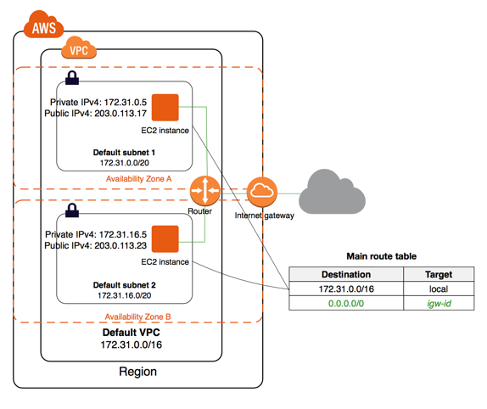
A subnet is a range of IP addresses in your VPC. You can launch AWS resources into a specified subnet. Use a public subnet for resources that must be connected to the internet, and a private subnet for resources that won't be connected to the internet.

The configuration for this scenario includes the following:
- A VPC with a size /16 IPv4 CIDR block (example: 10.0.0.0/16). This provides 65,536 private IPv4 addresses.
- A public subnet with a size /24 IPv4 CIDR block (example: 10.0.0.0/24). This provides 256 private IPv4 addresses. A public subnet is a subnet that's associated with a route table that has a route to an Internet gateway.
- A private subnet with a size /24 IPv4 CIDR block (example: 10.0.1.0/24). This provides 256 private IPv4 addresses.
- An Internet gateway. This connects the VPC to the Internet and to other AWS services.
- Instances with private IPv4 addresses in the subnet range (examples: 10.0.0.5, 10.0.1.5). This enables them to communicate with each other and other instances in the VPC.
- Instances in the public subnet with Elastic IPv4 addresses (example: 198.51.100.1), which are public IPv4 addresses that enable them to be reached from the Internet. The instances can have public IP addresses assigned at launch instead of Elastic IP addresses. Instances in the private subnet are back-end servers that don't need to accept incoming traffic from the Internet and therefore do not have public IP addresses; however, they can send requests to the Internet using the NAT gateway (see the next bullet).
- A NAT gateway with its own Elastic IPv4 address. Instances in the private subnet can send requests to the Internet through the NAT gateway over IPv4 (for example, for software updates).
- A custom route table associated with the public subnet. This route table contains an entry that enables instances in the subnet to communicate with other instances in the VPC over IPv4, and an entry that enables instances in the subnet to communicate directly with the Internet over IPv4.
- The main route table associated with the private subnet. The route table contains an entry that enables instances in the subnet to communicate with other instances in the VPC over IPv4, and an entry that enables instances in the subnet to communicate with the Internet through the NAT gateway over IPv4.

Can I create a peering connection to a VPC in a different region?
Yes. Peering connections can be created with VPCs in different regions. Customers can leverage VPC Peering across these commercial regions:
Can I peer my VPC with a VPC belonging to another AWS account?
Yes, assuming the owner of the other VPC accepts your peering connection request.
How many VPCs, subnets, Elastic IP addresses, Internet gateways, customer gateways, virtual private gateways, and VPN connections can I create?
You can have:
- 5 VPCs per AWS account per region
- 200 subnets per Amazon VPC
- 5 VPC Elastic IP addresses per AWS account per region
- 1 Internet gateway per VPC
- 5private gateways per AWS account per region
- 50 customer gateways per AWS account per region
- 10 IPsec VPN Connections per virtual private gateway

What is S3 bucket
simple storage service is a storage for internet
it is design for large capacity ,low-cost storage things across the multiple geographic regions

What kind and how much of data one can store in AWS S3?
You can store virtually any kind of data, in any format, in S3 and when we talk about capacity, the volume and the number of objects that we can store in S3 are unlimited.
data types- 3 storage classes
frequent data access
This is suitable for performance sensitive use cases where the latency should be kept low. e.g. in a hospital, frequently accessed data will be the data of admitted patients, which should be retrieved quickly.
infrequent data access
This is suitable for use cases where the data is long lived and less frequently accessed, i.e for data archival but still expects high performance. e.g. in the same hospital, people who have been discharged, their records/data will not be needed on a daily basis, but if they return with any complication, their discharge summary should be retrieved quickly.
Amazon Glacier
Suitable for use cases where the data is to be archived, and high performance is not required, it has a lower cost than the other two services.e.g. in the hospital, patients’ test reports, prescriptions, MRI, X Ray, Scan docs etc. that are older than a year will not be needed in the daily run and even if it is required, lower latency is not needed.
Isn’t anything free on AWS?”
Yes! As a part of the AWS Free Usage Tier, you can get started with AWS S3 for free. Upon sign up, new AWS customers receive 5 GB of Amazon S3 standard storage, 20,000 Get-Requests, 2,000 Put-Requests, and 15GB of data transfer-out each month for one year

How is S3 billed?
Though having so many features, AWS S3 is affordable and flexible in its costing. It works on Pay Per Use, meaning, you only pay what you use. The table below is an example for pricing of S3 for a specific region:
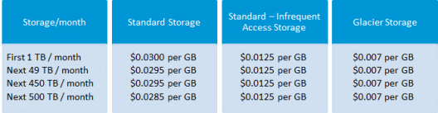

Step 1: Create a bucket
To create a bucket, navigate to S3 in the AWS Management Console and hit Create Bucket. You’ll be prompted to enter a name and a region.
If you plan on using your own domain/sub-domain, use that for your bucket name. For the region, pick the one closest to you and hit Create. With any luck, you’ll see your new bucket appear in the console.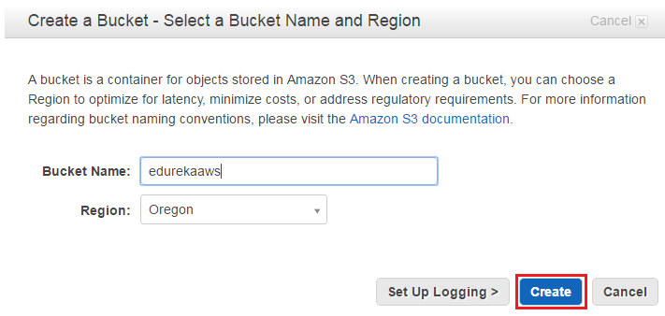
Step 2: Verify the Created Bucket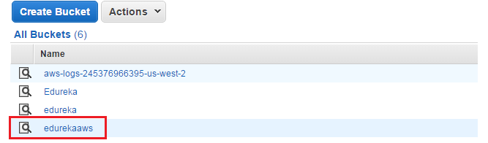
Step3: Enable Website Hosting
The only thing now left to do is, to enable Static Website Hosting. Just select it from the properties panel on the right.
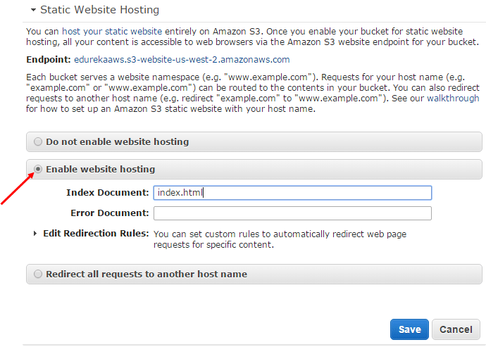
Step 4: Create a Html File
Make sure you set the Index Document to index.html. You can also set an error page if you want. When you’re done, hit Save.
One nice thing about the AWS Management Console is that you can upload files to your bucket right from your browser. Let’s start by creating one called index.html. This will be the contents of the home page:
<!doctype html>
<html>
<head>
<title>
Hello, S3!
</title>
<meta name="description" content="My first S3 website">
<meta charset="utf-8">
</head>
<body>
<h2>My first S3 website</h2>
<p>I can't believe it was that easy!</p>
</body>
</html>
Step 5: Upload the File in a Bucket
To upload the file, select your new bucket and hit Start Upload button.
Once you’ve uploaded index.html, it will appear in your bucket. However, you won’t be able to see it in your browser yet because everything in AWS S3 is private by default.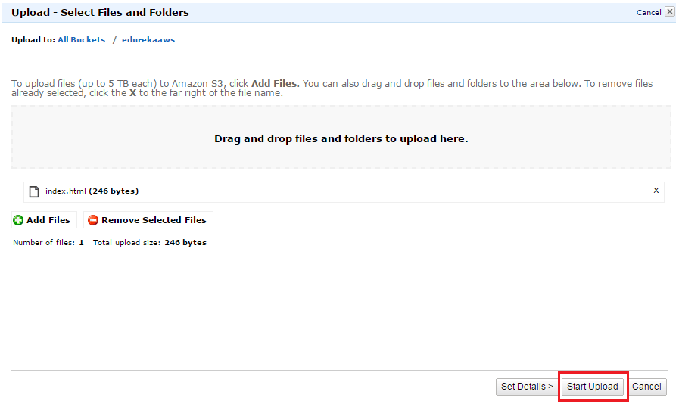
Step 6: Make the Html File Public
i) To make index.html file public, right-click on index.html and select Make Public. (Remember to do this for any other files you upload to your website!)
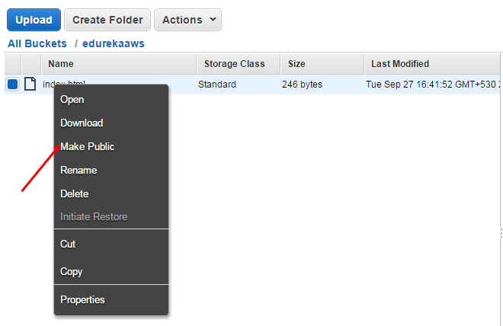
Now that your homepage is visible to the world, it’s time to test everything out!
ii) Now, select index.html in the console and go to the Properties tab.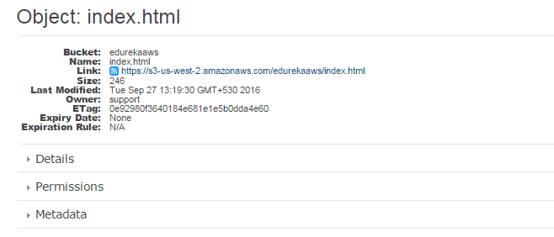
Step 7: Final Step to Verify the Result
Clicking the link will take you to your new homepage.
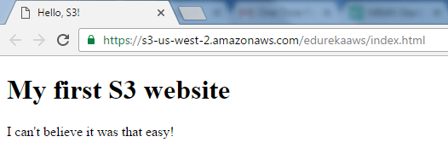
Congratulations! You have just hosted a html website in AWS using S3.
Here’s a short AWS S3 tutorial Video that explains: Traditional Storage Tiers, Disadvantages of Traditional Storage over Cloud, AWS storage options: EBS, S3, Glacier, AWS Connecting Storage: Snowball & Storage Gateway, AWS Command Line Interface (CLI), Demo etc. The AWS S3 tutorial is very important service for those who want to become AWS Certified Solutions Architect.

What is an Instance?
An instance is a virtual server for running applications on Amazon’s EC2. It can also be understood like a tiny part of a larger computer, a tiny part which has its own Hard drive, network connection, OS etc. But it is actually all virtual. You can have multiple “tiny” computers on a single physical machine, and all these tiny machines are called Instances.
Launch Instance.
- Select an AMI : because you require a Linux instance, in the row for the basic 64-bit Ubuntu AMI, click Select.
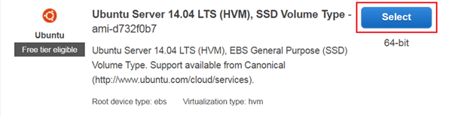

- Choose an Instance
Select t2.micro instance, which is free tier eligible.
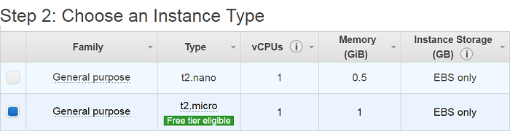
- Configure Instance Details.
Configure all the details and then click on add storage
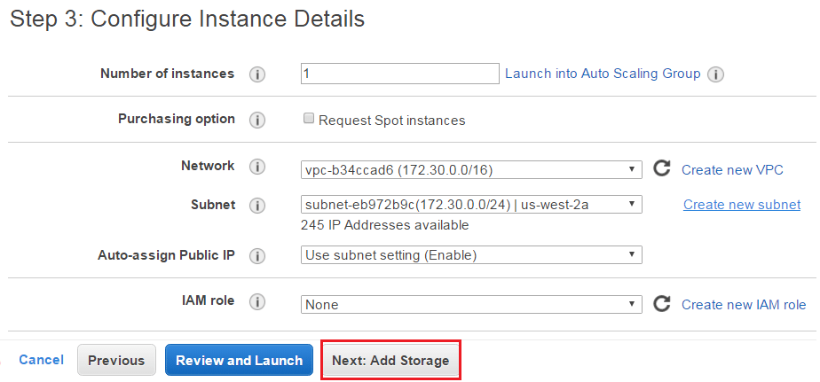

- Add Storage
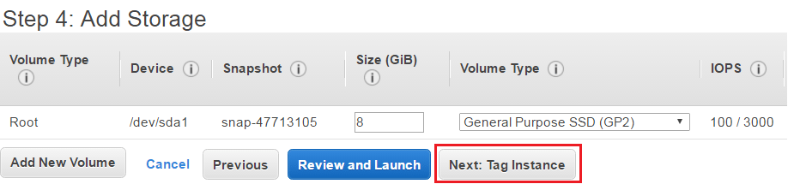
- Tag an Instance
Type a name for your AWS EC2 instance in the value box. This name, more correctly known as tag, will appear in the console when the instance launches. It makes it easy to keep track of running machines in a complex environment. Use a name that you can easily recognize and remember.
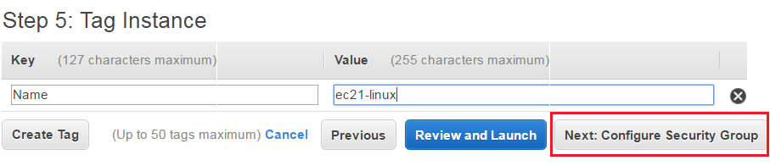
- Create a Security Group
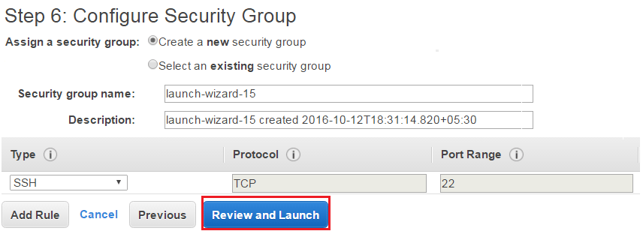
- Review and Launch an Instance
- Verify the details that you have configured to launch an instance.
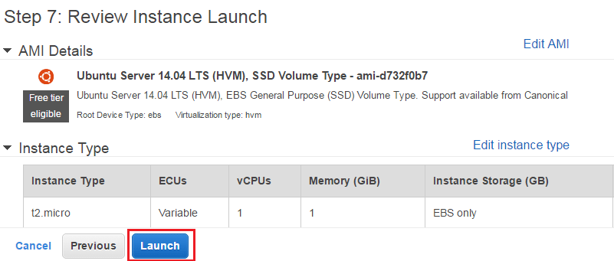

- Create a Key Pair & launch an Instance
Next in this AWS EC2 Tutorial, select the option ‘Create a new key pair’ and give a name of a key pair. After that, download it in your system and save it for future use.
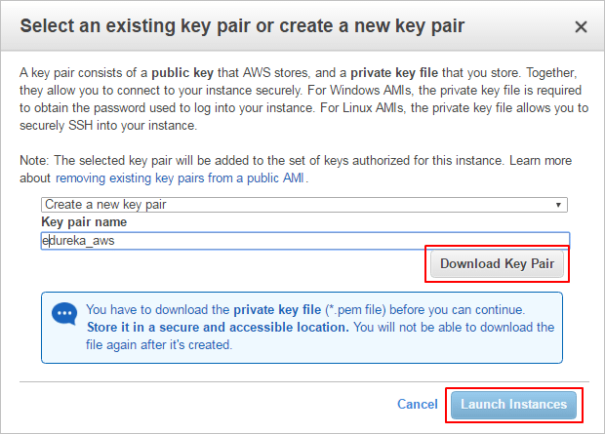

- Check the details of a launched instance.
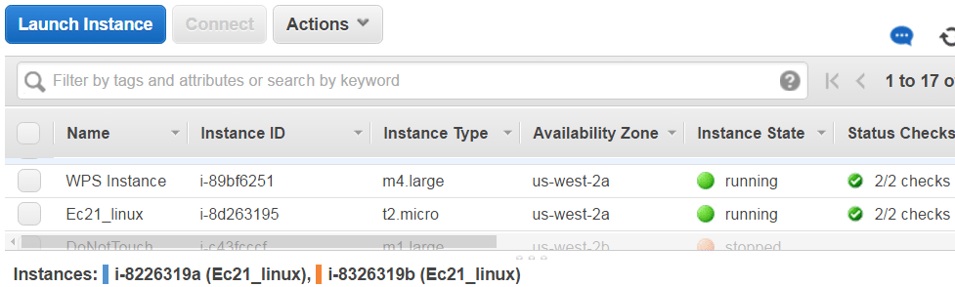

- Converting Your Private Key Using PuTTYgen
PuTTY does not natively support the private key format (.pem) generated by Amazon EC2. PuTTY has a tool called PuTTYgen, which can convert keys to the required PuTTY format (.ppk). You must convert your private key into this format (.ppk) before attempting to connect to your instance using PuTTY.
- Click Load. By default, PuTTYgen displays only files with the extension .ppk. To locate your .pem file, select the option to display files of all types.
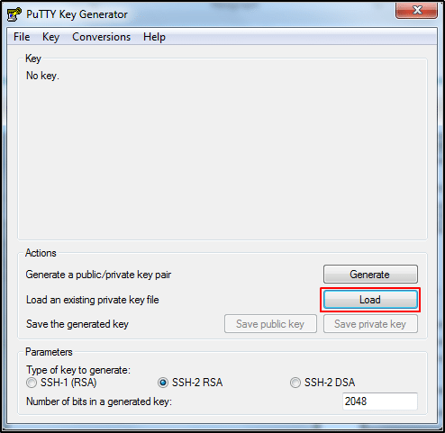
- Select your.pem file for the key pair that you specified when you launch your instance, and then click Open. Click OK to dismiss the confirmation dialog box.
- Click Save private key to save the key in the format that PuTTY can use. PuTTYgen displays a warning about saving the key without a passphrase. Click Yes.
- Specify the same name for the key that you used for the key pair (for example, my-key-pair). PuTTY automatically adds the. ppk file extension.
- Connect to EC2 instance using SSH and PuTTY
- Open PuTTY.exe
- In the Host Name box, enter Public IP of your instance.
- In the Category list, expand SSH.
- Click Auth (don’t expand it).
- In the Private Key file for authentication box, browse to the PPK file that you downloaded and double-click it.
- Click Open.
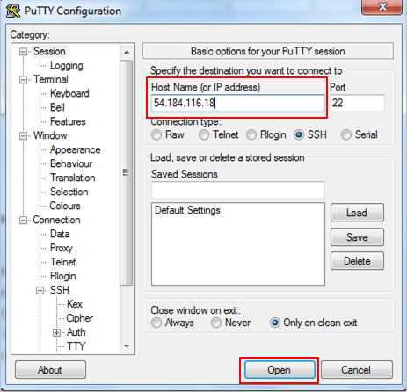
- Type in Ubuntu when prompted for login ID.
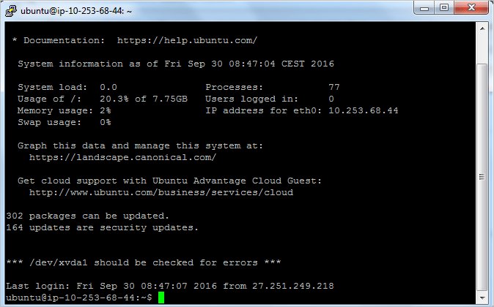
Congratulations! You have launched an Ubuntu Instance successfully.
Elastic Load Balancing
Elastic Load Balancing (ELB) automatically distributes incoming application traffic across multiple EC2 instances, in multiple Availability Zones.

